

**COMPUTER ENGINEERING**

**DS ODD SEM 2021-22/EXPERIMENT 2 NAME:- GAURAV AMARNANI (D7A, 67)**

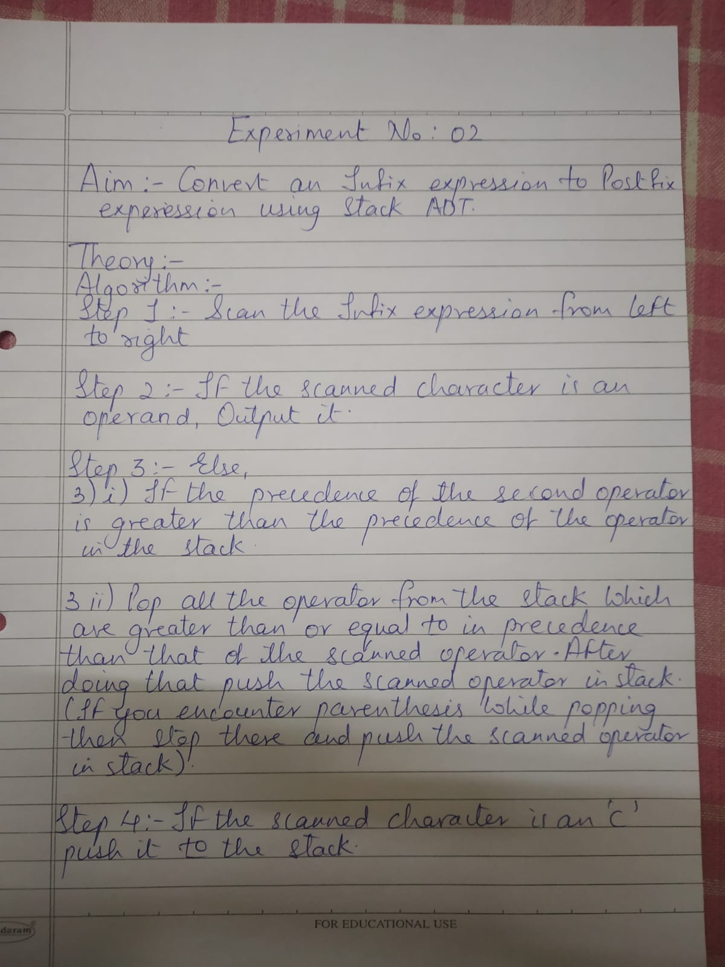

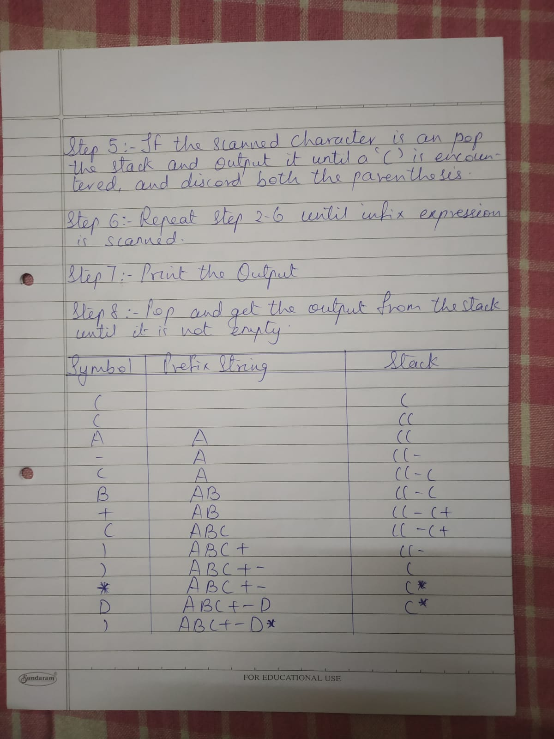

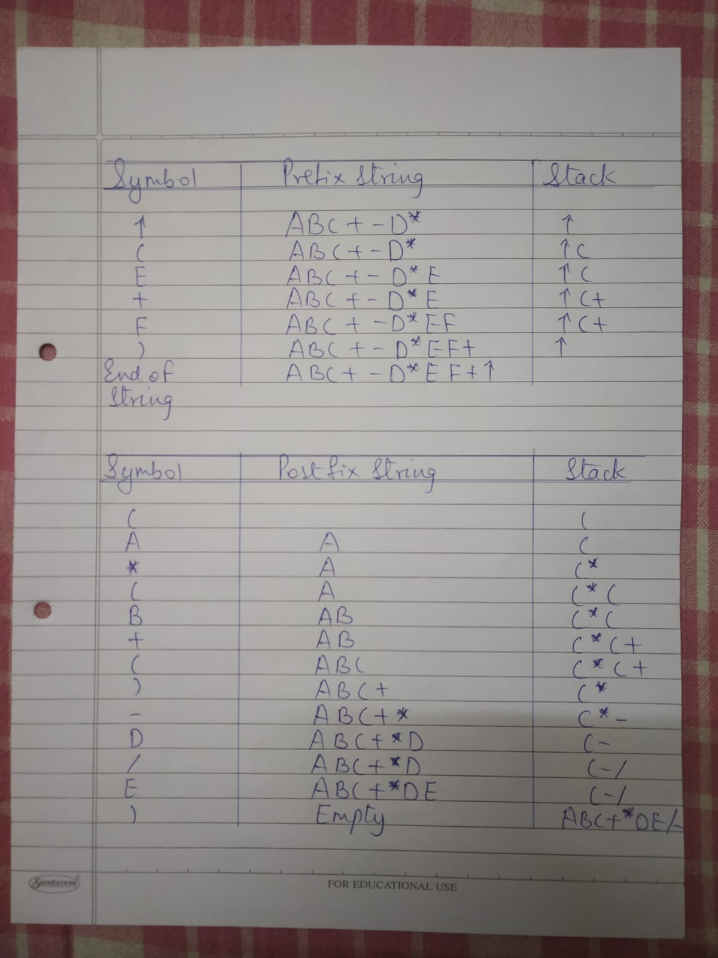

**PROGRAM NO 1: WRITE A PROGRAM TO IMPLEMENT STACK USING LINKED LIST**

#include<stdio.h>

#include<conio.h>

#define n 50

char stack[n];

int top=-1,j=0;

char postfix[50];

void push(char);

char pop();

int priority(char);

void main() {

int i;

char element,ch;

char infix[50];

printf("Expression:");

gets(infix);

printf("\ntoken\tStack \t postfix string");

for(i=0;infix[i]!=NULL;i++) {

ch=infix[i];

if(ch>='a' && ch<='z') {

postfix[j]=ch; j++;

}

else if(ch=='(') {

push(ch);

}

else if(ch==')') {

while((element=pop())!='(') {

postfix[j]=element; j++;

}

}

else {

while(priority(ch)<=priority(stack[top])) {

if(stack[top]=='(')

break;

element=pop();

postfix[j]=element;

j++;

}

push(ch);

}

postfix[j]=NULL;

printf("\n%c\t%s\t\t%s",ch,stack,postfix);

getch();

}

while((element=pop())!='(') {

postfix[j]=element;

j++;

}

getch();

}

void push(char ch) {

if(top>=n-1) {

printf("overflow");

}

else {

top=top+1;

stack[top]=ch;

}

}

char pop() {

char item;

if(top==- 1) {

printf("this is the postfix expression");

exit(0);

}

else {

top=top-1;

item=stack[top+1];

stack[top+1]=NULL;

}

return item;

}

int priority(char ch) {

char operand[6]={'+','-','*','/','(','\0'};

int prio[5]={1,1,2,2,3};

int i,a;

for(i=0;i<5;i++) {

if(ch==operand[i]) {

a=prio[i];

break;

}

}

return a;

}

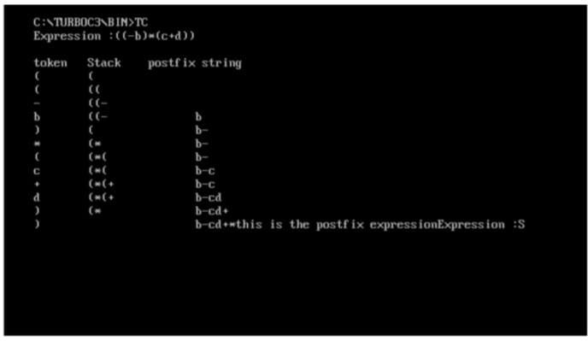OUTPUT:-